The database against which you’ll construct queries contains the following tables:

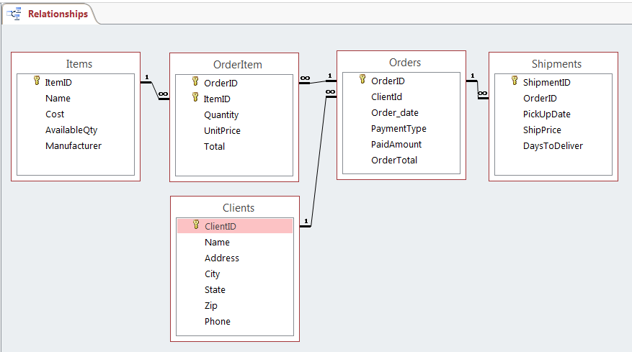

Clients (ClientID, CName, Address, City, State, Zip, Phone)
ClientID | CName | Address | City | State | Zip | Phone
1 | John Smith | 111 5th St | Denver | CO | 80111 | (720) 11-1111
2 | Mary Johnson | 222 4th St | Aurora | CO | 80022 | (720) 33-4321
3 | Alex Kupres | 333 3rd St | Denver | CO | 80222
4 | Max Smirnoff | 444 2nd St | Glendale | CO | 80333 | (303) 33-3333
5 | Dana Renes | 555 1st St | Denver | CO | 80033 | (720) 11-1234

Items (ItemID, IName, Cost, AvailableQty, Manufacturer)
Item  ID | IName | Cost | Available  Qty | Manufacturer
1 | Laptop | $1,500.00 | 25 | Sony
2 | Desktop | $800.38 | 17 | ViewSonic
3 | Monitor | $150.50 | 19 | ViewSonic
4 | Keyboard | $10.17 | 43 | Sony
5 | Mouse | $6.33 | 37 | Microsoft

Order: (OrderID, ClientID, Order_Date, PaymentType, PaidAmount, OrderTotal)
Order
OrderID | ClientId | Order  _date | Pay  mentType | Paid  Amount | Order  Total
1 | 1 | 1/1/2014 | Visa | $1,400.00 | $1,400.00
2 | 3 | 2/13/2013 | Check | $2,000.00 | $2,400.00
3 | 2 | 3/28/2013 | MasterCard | $1,300.00 | $1,300.00
4 | 4 | 4/12/2013 | Visa | $2,000.00 | $2,060.00
5 | 1 | 7/30/2013 | Check | $800.00 | $3,200.00
6 | 1 | 9/18/2013 | Visa | $185.00 | $185.00
7 | 5 | 11/3/2013 | Visa | $0.00 | $1,720.00

OrderItem (OrderID, ItemID, Quantity, UnitPrice, ItemTotal)
OrderItem
OrderID | ItemID | Quantity | UnitPrice | ItemTotal
1 | 1 | 1 | $1,400.00 | $1,400.00
2 | 1 | 1 | $1,600.00 | $1,600.00
2 | 3 | 2 | $400.00 | $800.00
3 | 2 | 1 | $1,300.00 | $1,300.00
4 | 1 | 1 | $1,500.00 | $1,500.00
4 | 3 | 1 | $440.00 | $440.00
4 | 4 | 3 | $30.00 | $90.00
4 | 5 | 3 | $10.00 | $30.00
5 | 1 | 2 | $1,600.00 | $3,200.00
6 | 4 | 7 | $20.00 | $140.00
6 | 5 | 5 | $9.00 | $45.00
7 | 2 | 1 | $1,320.00 | $1,320.00
7 | 3 | 1 | $400.00 | $400.00

Shipments
ShipmentID | Order  ID | PickUp  Date | Ship  Price | DaysTo  Deliver
1 | 1 | 1/3/2014 | $25.00 | 3
2 | 6 | 9/19/2013 | $17.50 | 5
3 | 6 | 9/21/2013 | $27.40 | 3
4 | 3 | 3/30/2013 | $38.25 | 3
5 | 2 | 2/15/2013 | $45.07 | 5
6 | 5 | 8/2/2013 | $33.03 | 3
7 | 4 | 4/15/2013 | $27.48 | 4
8 | 7 | 11/5/2013 | $45.90 | 5

Use Query Design View to complete the following queries. Make sure your query would produce the result as given in the hints. However, you cannot use the information given in the hints in the construction of your query. Instead, use only information stated in the problem itself and use the hints to verify that your query was constructed correctly.

Observe the following rules when constructing your queries:
- Use only necessary tables (points deducted otherwise).
- Use only information given in the questions (points deducted otherwise). For example, in Query06, customer id is not given. So in constructing your query, do not use the criterion that customerid is 1; instead, only use the criterion that customer name is John Smith.
- Display only those fields mentioned in the question (points deducted otherwise).

You must name your queries query01, query02 … query06…query14.—Points are evenly distributed.

(01). For all orders placed after 11/1/2013, show orderId, order_date, clientId, client name, and all batches of shipping information (shipprice and pick up date). Hint: correct query should return two rows of data.

(02). Find all Orders that were paid with a payment type other than Check. Show OrderId, order date, ClientId, and Payment Type for each such order. Hint: Correct query should return 5 rows of data.

(03). Find all orders that ordered a ViewSonic product and were paid with a Check. Show OrderId and Orderdate for all such orders. (Hint: correct query should return 1 such order).

(04). Find the names of all customers who have ordered a laptop. Show clientid and client name for all such customers. Hint: correct query should return 4 names, with two of them being the same.

(05). Find all orders that ordered a desktop. Show OrderId, OrderDate, and Quantity Ordered. Please note that you can’t use ItemId =2 in the query because this information is not given to you in the question itself. You’re given the information that IName is desktop, not ItemId is 2. Hint: correct query should return 2 such orders.

(06). Show all shipments where the ship price is greater than $35. Show all shipment information. (Hint: correct query should return three rows of data).

(07). For all orders occurred during the first quarter of 2013 (i.e., from January 1 to March 31), show orderId, clientId, Month of order, and Year of order. Hint: This will require Year function and Month function. Correct query should return the following information:
Query07
OrderID | ClientId | MonthOfOrder | YearOfOrder
2 | 3 | 2 | 2013
3 | 2 | 3 | 2013

(08). Show all orders occurred on the 28th of any month in 2013. Show order id. Hint: correct query should return 3 such orders.

(09). For all customers who have ordered a laptop, identify those orders that have an OrderTotal greater than $3,000. Show customer name, order total and product name. Hint: Correct query obtain the following output:

Query06
CName | OrderTotal | IName
JOHN SMITH | $3,200.00 | Laptop

(10). Find the most recent Order_date, earliest Order_Date, highest order total, and lowest order total in one query. Hint, correct query should return the following:

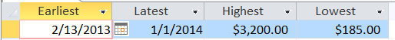

(11). UsingOrderItem table, find the total revenue from each Item. (Hint: correct query should return the following result. It’s Ok if your output columns are named differently from the output shown.)

Query11
ItemID | total
1 | $7,700.00
2 | $2,620.00
3 | $1,640.00
4 | $230.00
5 | $75.00

(12). How many laptops have been sold? Show this quantity. (Hint: correct result should return 5.)

(13) For products with a cost higher than 800, how many of them have been sold and how much revenue have they brought in? (Hint: correct result should return 7 for quantity and $10,320.00 for revenue.)

(14). Using Order table, find the total amount paid with a credit card (Visa, Mastercard). Show this total only. (Hint: Correct result should return 4,885.00).

(Note, #13 and #14 may be removed depending on coverage on 2/6.)

